**Lesson 5 Demo 1**

**Understanding kube-scheduler**



Steps to be followed:

1. Understanding kube-scheduler commands
2. Creating a configuration file

**Step 1: Understanding kube-scheduler commands**

* 1. Write the following command to understand kube-scheduler commands:

***kube-scheduler --help***

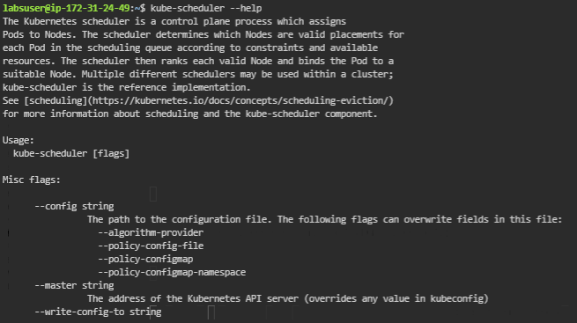

**Step 2: Creating a configuration file**

1. Create a config file with the following command:

***vi samplekubescheduler.yaml***



1. Write the following code in the file:

***apiVersion: v1***

***kind: Pod***

***metadata:***

***labels:***

***component: kube-scheduler***

***tier: control-plane***

***name: kube-scheduler***

***namespace: kube-system***

***spec:***

***containers:***

***- command:***

***- /bin/sh***

***- -c***

***- exec /usr/local/bin/kube-scheduler --v=2 --kubeconfig=/etc/srv/kubernetes/kube-scheduler/kubeconfig***

***1>>/var/log/kube-scheduler.log 2>&1***

***image: k8s.gcr.io/kube-scheduler:v1.9.7***

***livenessProbe:***

***httpGet:***

***host: 127.0.0.1***

***path: /healthz***

***port: 10251***

***initialDelaySeconds: 15***

***timeoutSeconds: 15***

***name: kube-scheduler***

***resources:***

***requests:***

***cpu: 75m***

***volumeMounts:***

***- mountPath: /var/log/kube-scheduler.log***

***name: logfile***

***readOnly: false***

***- mountPath: /etc/srv/kubernetes***

***name: srvkube***

***readOnly: true***

***hostNetwork: true***

***volumes:***

***- hostPath:***

***path: /etc/srv/kubernetes***

***name: srvkube***

***- hostPath:***

***path: /var/log/kube-scheduler.log***

***type: FileOrCreate***

***name: logfile***

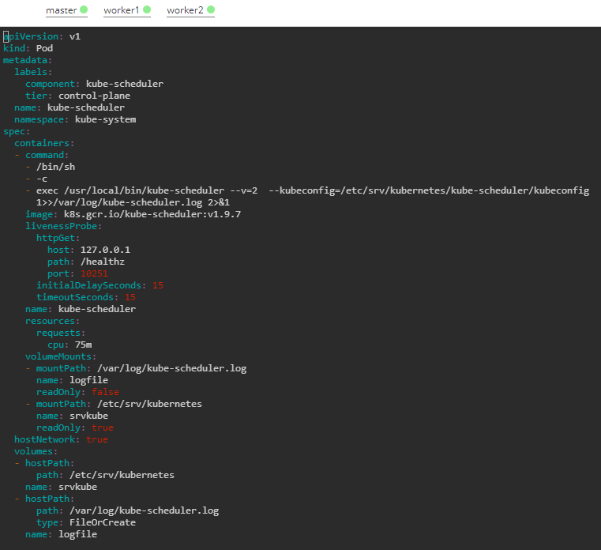

| **Note:** Press ***ecs*** button and type ***:wq*** to save the file and exit the text editor. |
| --- |

1. Write the command to create the pod:

***kubectl apply -f samplekubescheduler.yaml***

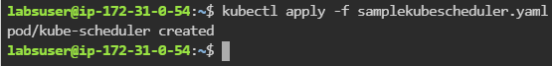

1. Write the command to list all the pods:

**kubectl get pods -A**

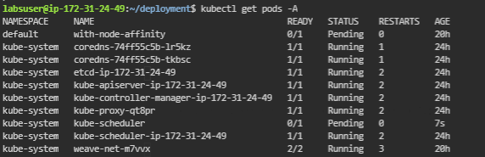

| **Note:** This will list all the pods that belong to all the namespaces. |
| --- |